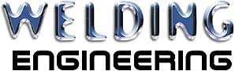
Welders Excellence Award
Springvale Road,
Darwen, Lancashire, BB3 2ES.
Tel: 01254 773718 Fax: 01254 700252
Email: all@welding-eng.com
October Winner

Date reported: - 28/10/2010
Department: - WEC Engineering
Job Description: Corus Fixed Hood

Welder responsible: William Barr

